**Exercise 5: Triggers**

Scenario 1: Automatically update the last modified date when a customer's record is updated.

**PL/SQL Code:**

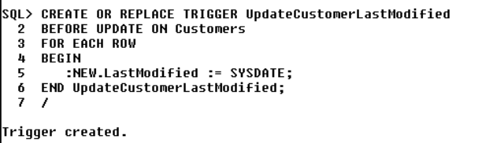

**Output:**

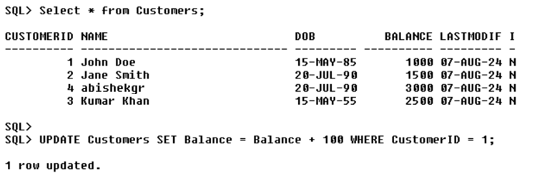

Scenario 2: Maintain an audit log for all transactions.

**Creating AuditLog table to store audit log for all transactions:**

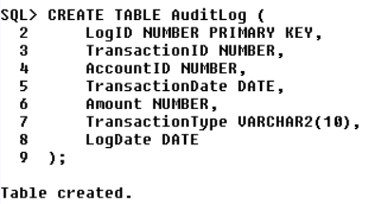

**PL/SQL Code:**

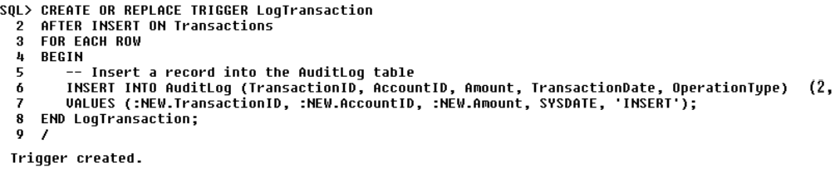

**Output:**



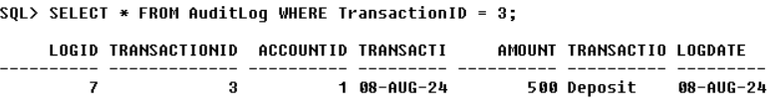

Scenario 3: Enforce business rules on deposits and withdrawals.

**PL/SQL Code:**

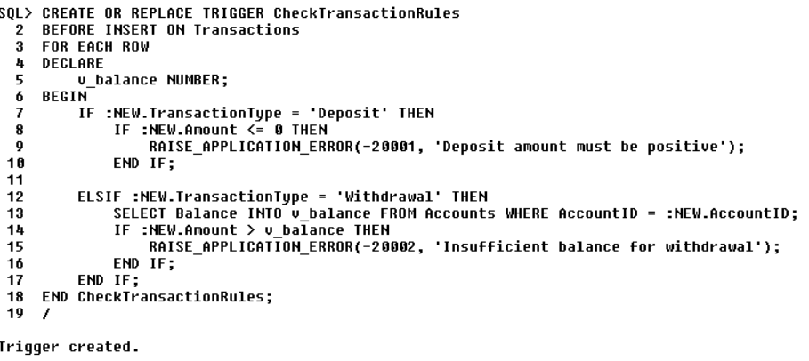

**Output:**

